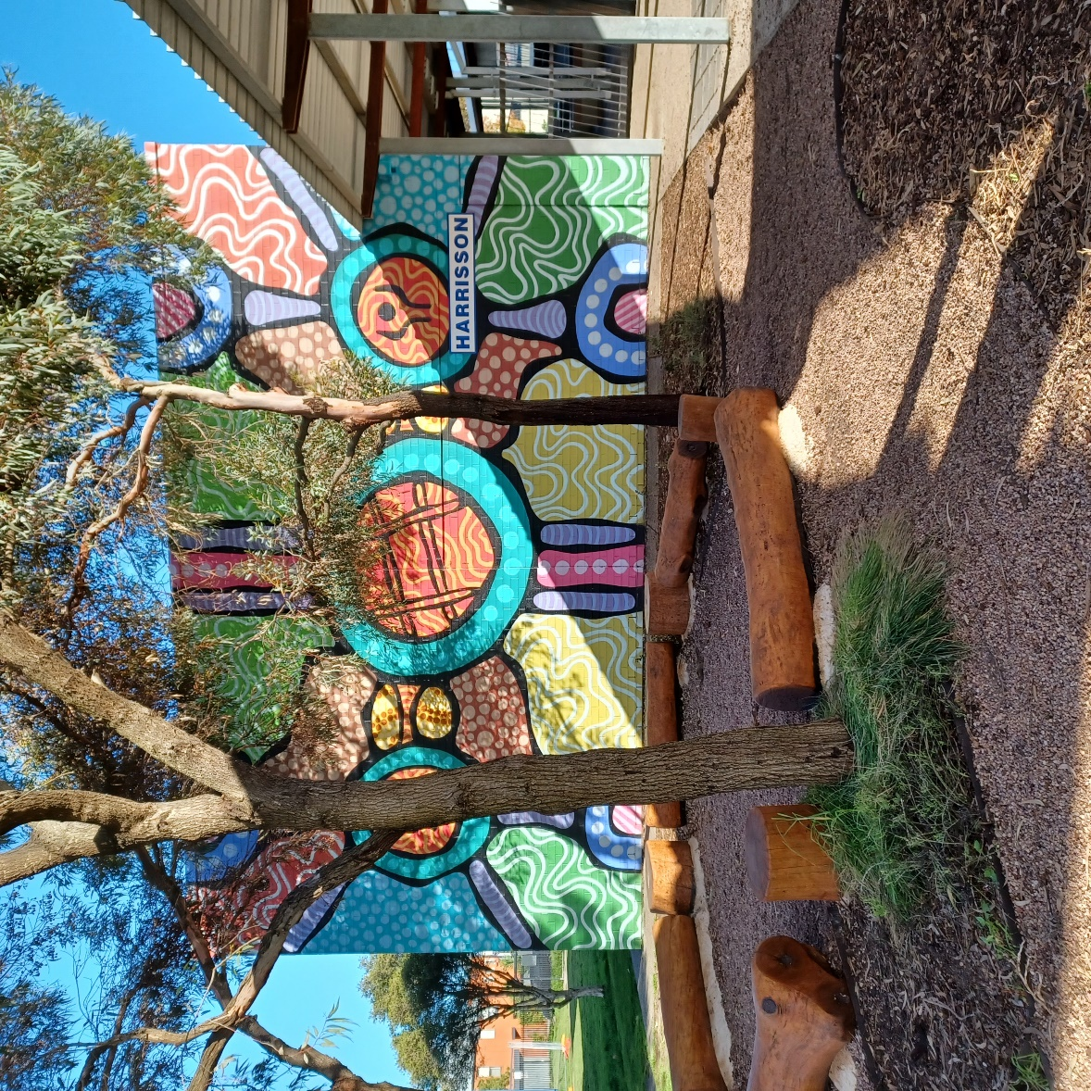

Newsletter
Term 1 Week 3
14th February 2024

https://sway.cloud.microsoft/IUhsc6ZIljJ9m0kB?ref=Link

